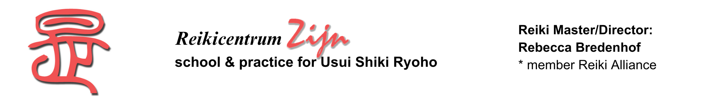

REGISTRATION FORM

I hereby register for the 2nd degree Reiki class of:
26 and 30 November plus 1 December 2024

Times: Tuesday 26 November: 3pm – 5pm
Saturday 30 November and Sunday 1 December: 9.30am – ± 1pm

Name: Date of birth:

Adress:

Postal code and residence:

Phone number: Email:

Date 1st degree Reiki class: Name master:

The investment for this 2nd Reiki degree is € 605,-- (incl 21% vat). This amount I will take with me in cash in an envelope at the start of the class.

Date: Signature :

You can send the completed and signed form, plus your motivation for receiving the
2nd Reiki degree, by email to reikicentrum.zijn@hetnet.nl

Or by regular mail to (also location for the class):
Reikicentrum Zijn
Attn Rebecca Bredenhof
Johannes Camphuysstraat 150-152
2593 CT Den Haag

a.b.: | e-mail: | conf.let:

