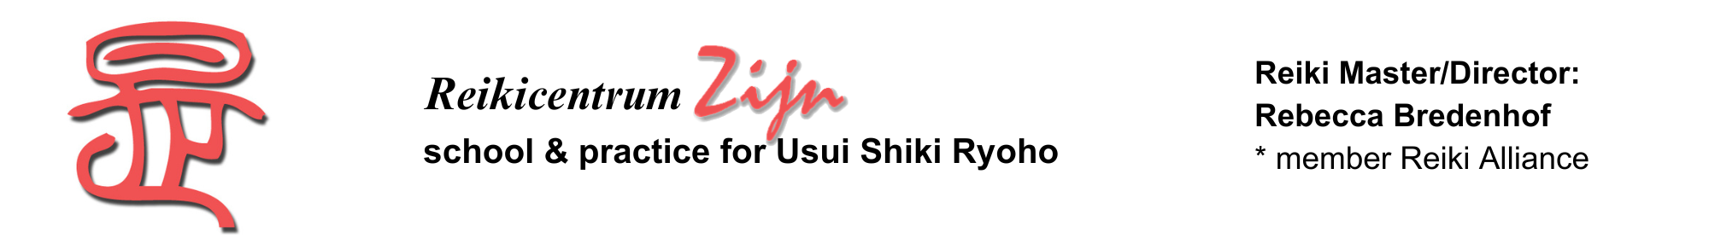
REGISTRATION FORM

Hereby I register for the 2nd degree graads Reiki class of 8, 11 en 12 July 2025

Times: Tuesday 8 July from 4pm – 6 pm
Friday 11 July from 7pm – 10.30pm
Saturday 12 July from 9.30am – ± 1pm

Name: Date of birth:

Adress:

Postal code and resideance:

Phone number: Email:

Date 1st degree Reiki class: Name master:

The investment for the 2nd Reiki degree is € 605,-- (incl 21% vat).
I will pay in cash at the start of the class.

Date: Signature :

You can email the completed and signed form, plus your motivation for receiving the 2nd Reiki degree, to reikicentrum.zijn@hetnet.nl

Or by mail to (also the location for the class):
Reikicentrum Zijn
attn. Rebecca Bredenhof
Johannes Camphuysstraat 150-152
2593 CT Den Haag

a.b.: | e-mail: | bev.brf:

